Housing Prices in Metropolitan Areas of India

INTRODUCTION:

India, one of the world's most populous and rapidly urbanizing nations, has witnessed significant transformations in its real estate landscape, particularly in its metropolitan areas. As the country's urban population continues to surge, driven by factors such as rural-to-urban migration and economic opportunities in cities, the dynamics of the housing market in Indian metropolises have become a subject of both fascination and concern.

Metropolitan areas in India, characterized by their bustling cities, economic hubs, and diverse cultural landscapes, have long been magnets for job seekers and entrepreneurs. These regions, which include megacities like Mumbai, Delhi, Bangalore, Chennai, and Kolkata, offer a unique tapestry of opportunities and challenges when it comes to housing.

PURPOSE:

1. Market Analysis: To understand the current trends and dynamics in the housing market of Indian metropolitan areas, providing valuable insights to homebuyers, investors, and real estate professionals.
2. Public Awareness: To raise awareness among the general public about the challenges and opportunities in the housing market in metropolitan regions, promoting informed civic engagement.
3. Socioeconomic Impact: To analyse how housing prices affect the socioeconomic composition of metropolitan areas, including issues related to income inequality, gentrification, and access to housing.
4. Consumer Guidance: To offer guidance and information to potential homebuyers on navigating the housing market in metropolitan areas, including tips for negotiating prices and securing mortgages.
5. Market Analysis: To understand the current trends and dynamics in the housing market of Indian metropolitan areas, providing valuable insights to homebuyers, investors, and real estate professionals.
6. Public Awareness: To raise awareness among the general public about the challenges and opportunities in the housing market in metropolitan regions, promoting informed civic engagement.
7. Socioeconomic Impact: To analyse how housing prices affect the socioeconomic composition of metropolitan areas, including issues related to income inequality, gentrification, and access to housing.
8. Consumer Guidance: To offer guidance and information to potential homebuyers on navigating the housing market in metropolitan areas, including tips for negotiating prices and securing mortgages.

PROBLEM DEFINITION & DESIGN THINKING

Empathy Map

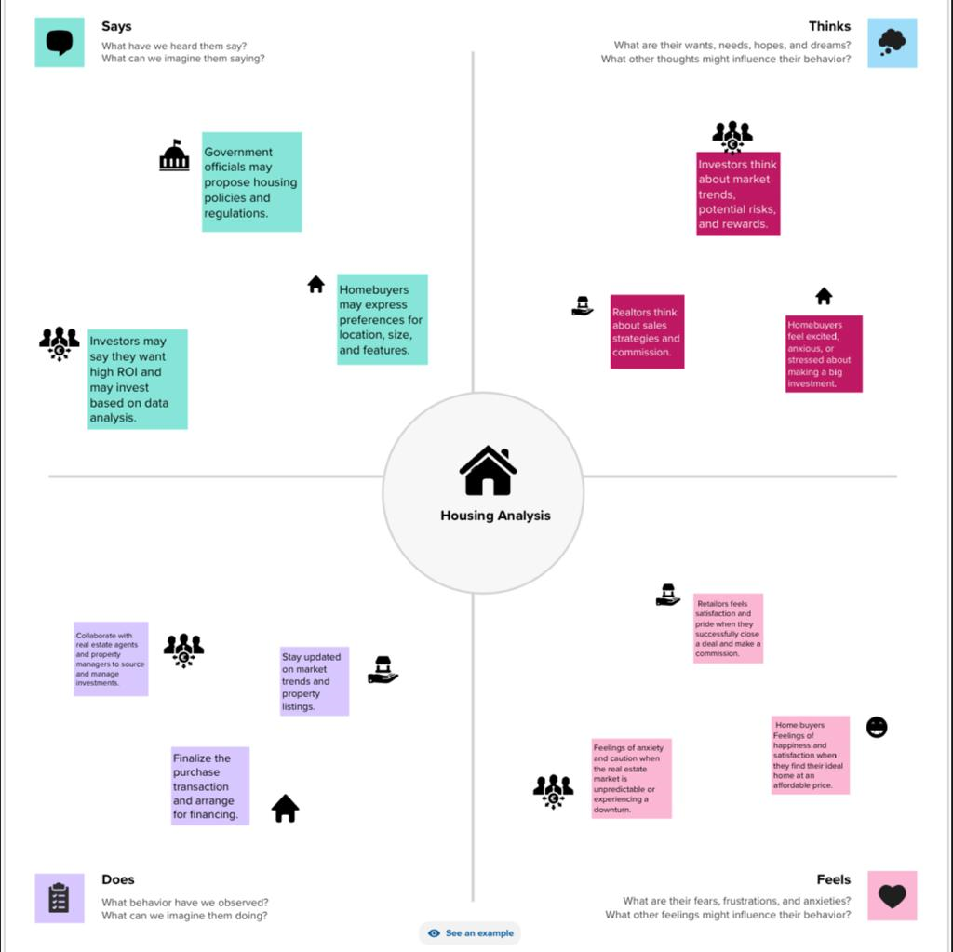

IDEATION AND BRAINSTROMING MAP:

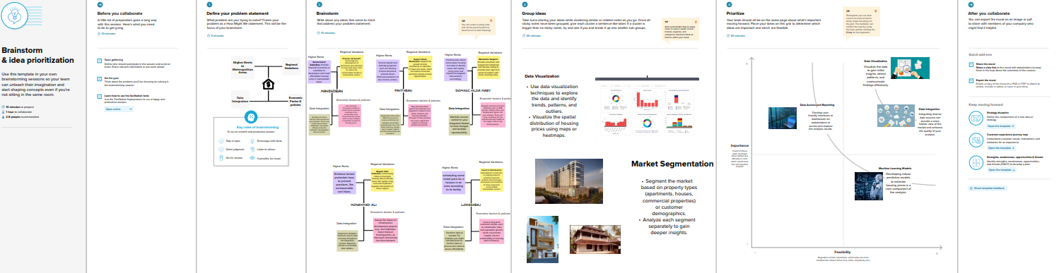

RESULT:

Government policies and regulations play a pivotal role in influencing housing prices. Measures to promote affordable housing, regulate property transactions, and provide incentives can shape the market. Housing prices have significant socioeconomic implications. While they offer investment opportunities, they can also contribute to income inequality and issues like gentrification, affecting the social fabric of metropolitan areas. The future of housing prices in Indian metropolitan areas remains uncertain and subject to various factors, including economic trends, policy changes, and global events.

As the urbanization trend continues, it is essential for policymakers, urban planners, investors, and individuals to closely monitor and adapt to these dynamics. Balancing affordability, sustainability, and quality of life in metropolitan areas will be an ongoing challenge, requiring a multifaceted approach that considers both economic and societal factors.

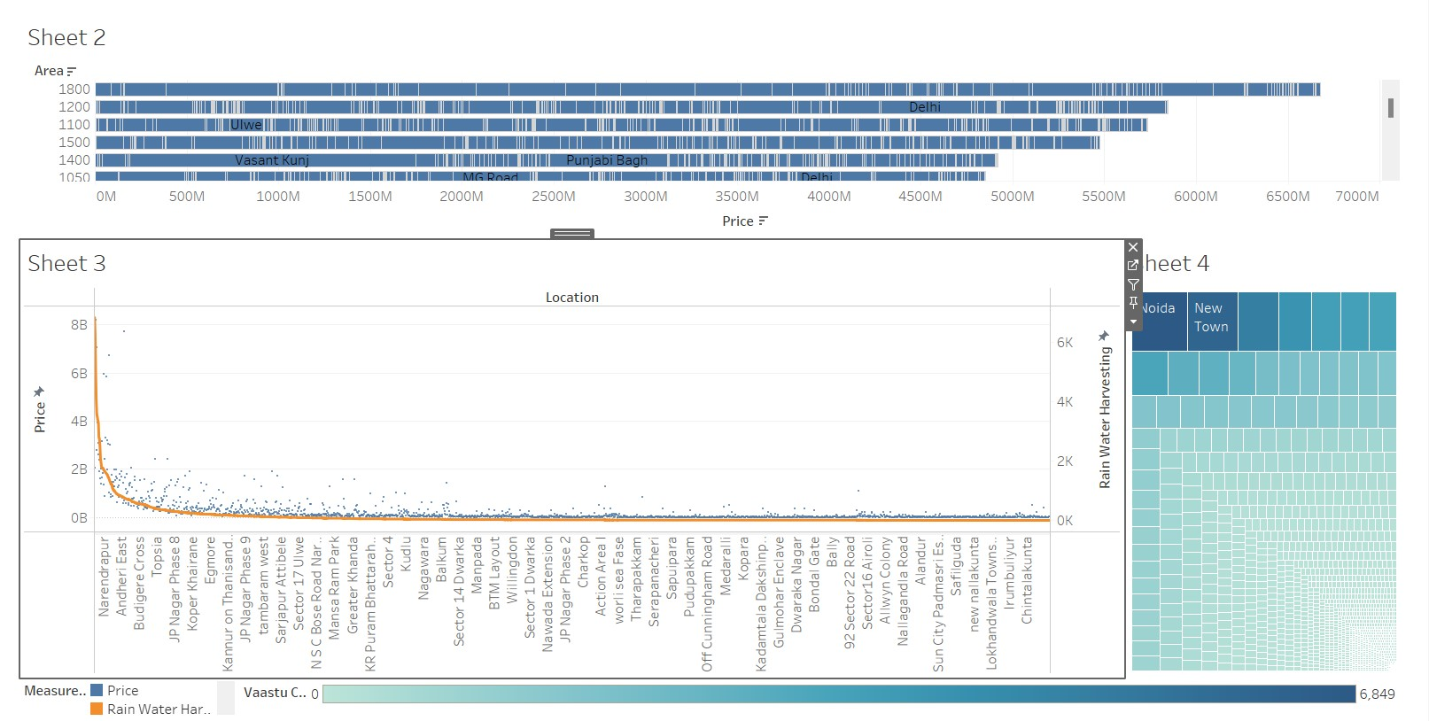

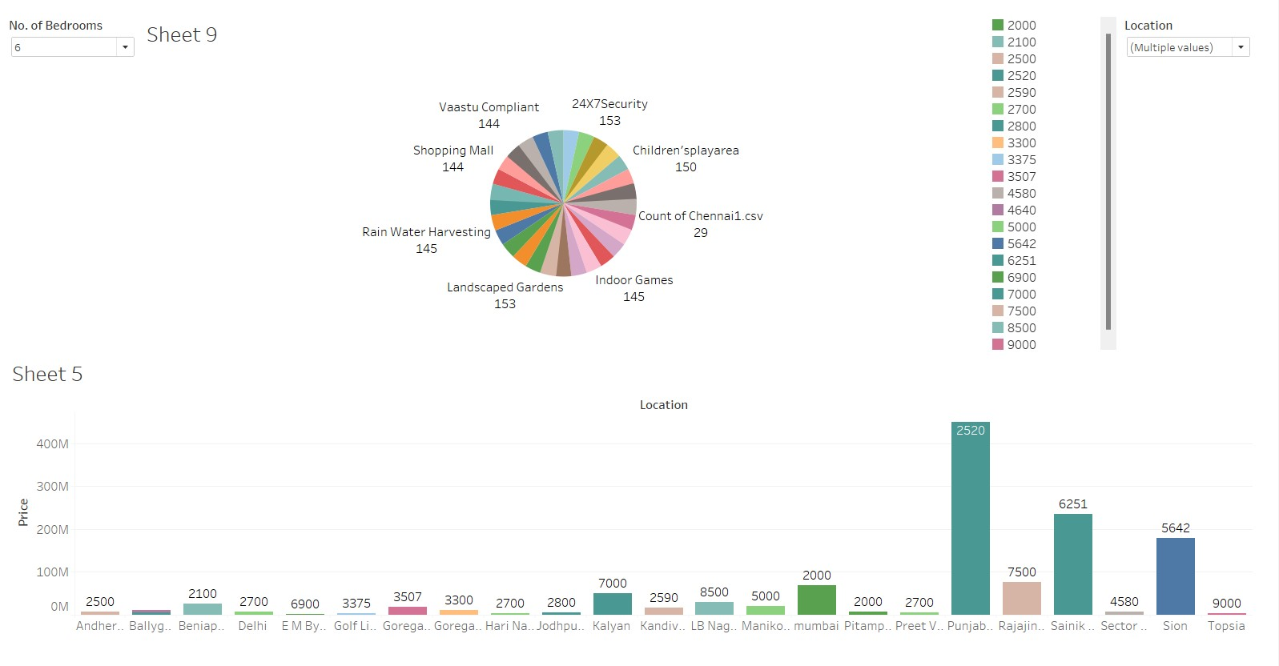

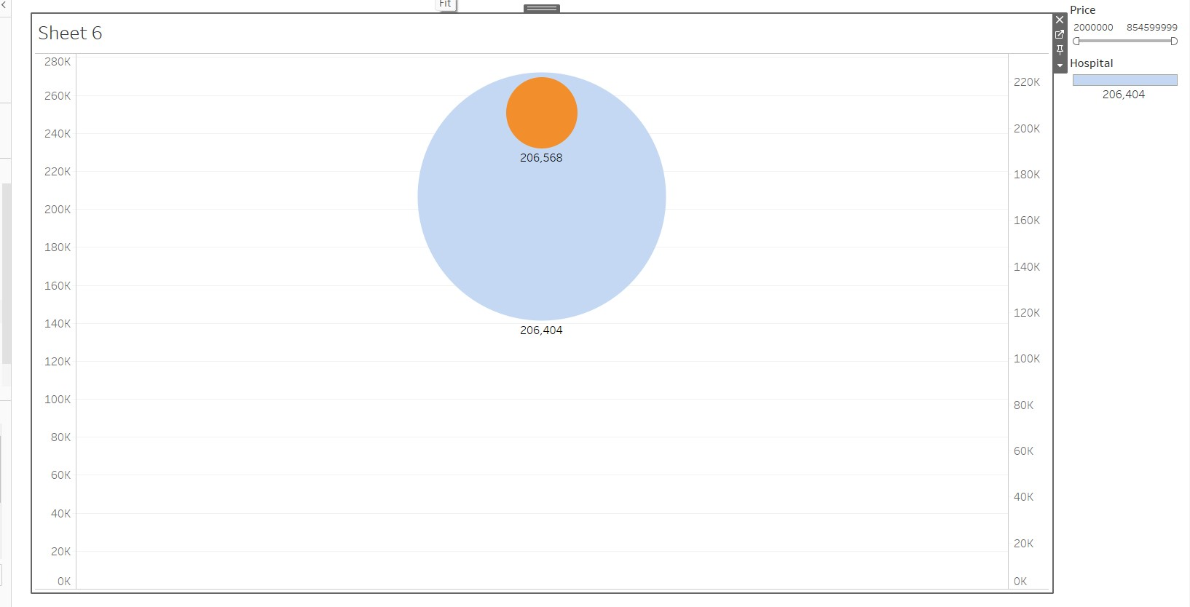

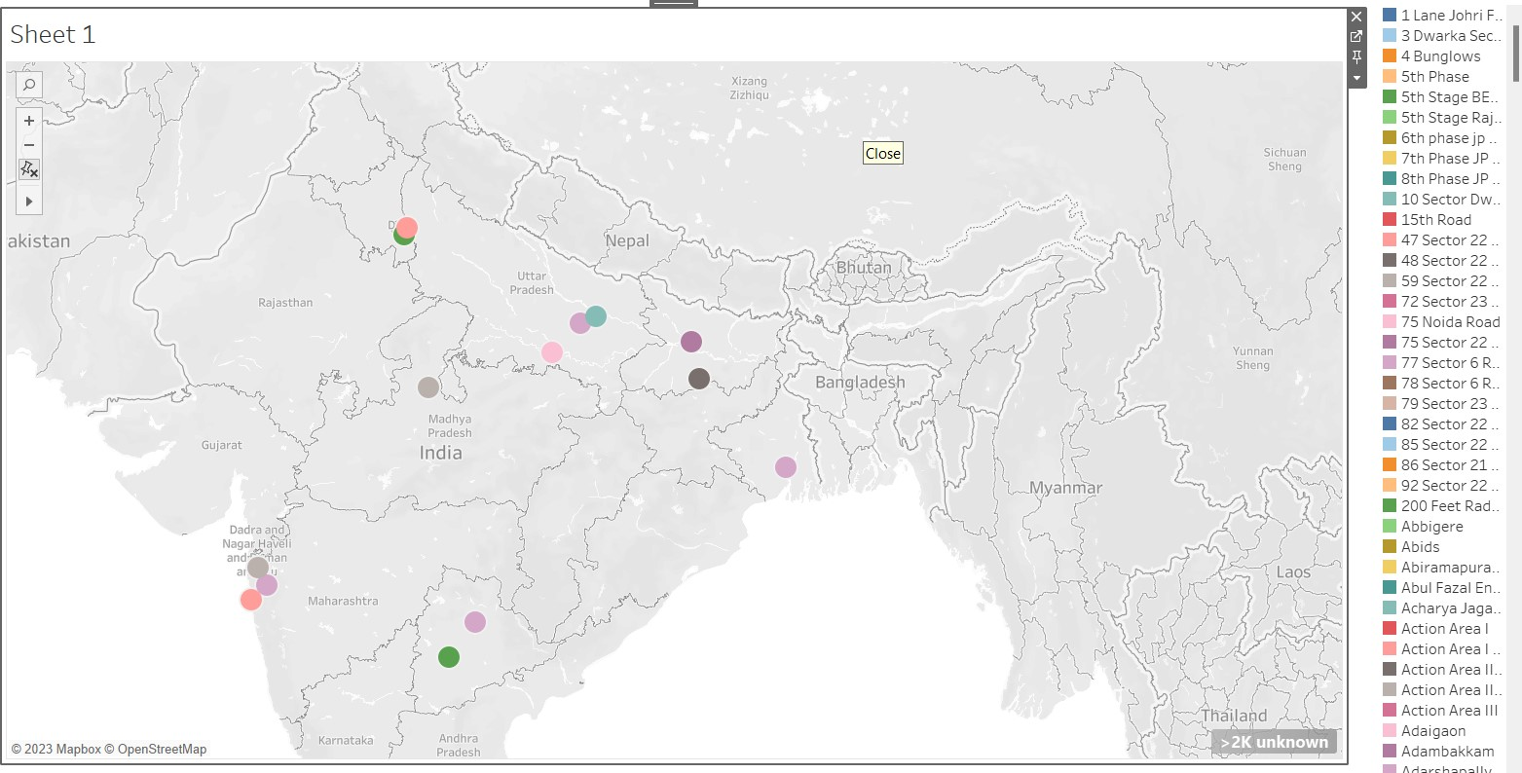

ADVANTAGES & DISADVANTAGES:

Advantages:

1. Economic Indicator: Housing prices in metropolitan areas serve as an essential economic indicator. They can reflect the overall economic health of a region, including job opportunities, income levels, and consumer confidence.
2. Urban Planning: Knowledge of housing prices informs urban planning decisions. It helps city planners allocate resources for transportation, infrastructure, and public services to accommodate population growth and changing housing needs.
3. Real Estate Investment: Investors use information on housing prices to identify potential investment opportunities. It allows them to allocate capital strategically in areas with growth potential, thereby increasing their returns.
4. Consumer Protection: Knowledge of housing prices empowers consumers by allowing them to make informed choices, avoid overpaying for properties, and negotiate better deals.
5. Infrastructure Development: Cities can use information on housing prices to prioritize infrastructure projects such as transportation, utilities, and public services to meet the needs of growing populations.
6. Informed Decision-Making: Understanding housing prices helps individuals and investors make informed decisions about buying, selling, or investing in real estate. This knowledge can lead to better financial outcomes and minimize risks.

DISADVANTAGES:

1. Government Intervention Risks: While government policies can stabilize housing markets, they can also have unintended consequences if not well-planned. Policies designed to control prices can sometimes distort the market.
2. Data Bias: Housing price data may be subject to biases, such as reporting inaccuracies or incomplete data, which can affect the reliability of analyses and forecasts.
3. Limited Data Availability: Access to accurate and up-to-date data on housing prices can be limited, especially in emerging or less-regulated markets. This can hinder comprehensive analysis and decision-making.
4. Inequality and Gentrification: Rapid increases in housing prices can lead to gentrification, displacing lower-income residents and increasing income inequality in metropolitan areas.
5. Environmental Impact: Expanding metropolitan areas to accommodate housing demand can have adverse environmental impacts, such as increased traffic congestion and pollution.
6. Data Privacy Concerns: Collecting and sharing housing price data can raise privacy concerns, as it may involve disclosing personal information about homeowners and transactions.

APPLICATION:

* Real estate Investment
* Home buying and renting
* Financial planning
* Housing affordability
* Economic indication
* Consumer protection
* Environmental impact assessment
* Infrastructure investment

CONCLUSION:

In summary, the study of housing prices in Indian metropolitan areas is instrumental in shaping urban development, economic growth, and social equity. It provides critical information for individuals, businesses, policymakers, and researchers to navigate the complexities of the housing market and work towards creating livable, sustainable, and inclusive metropolitan environments in India. As metropolitan areas continue to evolve, this topic remains a key focal point for informed decision-making and societal progress.

FUTURE SCOPE:

Smart Cities and Infrastructure: As India's Smart Cities Mission advances, research will focus on how housing prices are affected by investments in smart infrastructure, such as IoT technology, renewable energy, and efficient transportation systems.

Housing for Sustainability: With a growing focus on sustainability and climate change, future research will explore how housing prices can be influenced by environmental factors, such as proximity to green spaces or energy-efficient features.

Big Data Integration: Integrating data from various sources, including social media, economic indicators, and urban development projects, will provide a more comprehensive understanding of housing market dynamics.

Real Estate Technology : The integration of technology into the real estate sector will continue to evolve, impacting property valuation, market transparency, and the overall real estate transaction process.

Economic Resilience: Research will explore how housing markets in metropolitan areas can build resilience to economic shocks, including global crises, by examining the role of housing as an asset class.

Thank you